**NESTOR A. TRINIDAD CONSTRUCTION AND TRADING**

**FINAL PROJECT**

**ITEC 50 – Web System and Technologies**

Submitted to

**PROF. JEFFREY F. PAPA**

Instructor III  
Information Technology Department  
Cavite State University Naic  
Bucana, Naic, Cavite

JUDE ALLAN CHICA

MA. LUISA CARLA TRINIDADMay 2019

**TABLE OF CONTENTS**

Title Page ……………………………………………………………………………. 1

**Table of Contents** ……………………………………………………………………. 2

Company Background ……………………………………………………. 3

Company History (if any) ……………………………………………………. 3

Company Location (Google map) ……………………………………………. 8

Organizational Chart ……………………………………………………………. 9

Gallery (Business Establishment) ……………………………………………. 10

Web Content (what are the pages of the websites) ……………………………. 11

Sitemap ……………………………………………………………………. 11

Screenshot (User Interface with description) ……………………………………. 12

Source code ……………………………………………………………………. 16

About the Developers ……………………………………………………………. 32

Evaluation Result ……………………………………………………………. 33

**COMPANY BACKGROUND**

Home is where we raise our families and experience most of life's greatest joys. It's where the vast majority of our memories are maid. We'll never forget that. At cutting edge trim, WE DON'T FINISH HOUSES, WE FINISH HOMES.

**MISSION**

To provide reliable, top quality carpentry services to the building industry.

**VISION**

To help to contribute a comfortable lifestyle and work environment for our clients, employees and of course the end users of our products.

**NESTOR A. TRINIDAD CONSTRUCTION AND TRADING CERTIFICATE NO. 04736384** were established in Province of Cavite for Housing Project Land Development and other construction project. Our scope of service is to maintain highly skilled of construction working forces. **NESTOR A. TRINIDAD CONSTRUCTION AND TRADING** ensure that the client is given a total service contract.

**NESTOR A. TRINIDAD CONSTRUCTION AND TRADING** maintained in the preparation of technical and project monitoring and control financial management and overall project administration. It has also equipment for faster implementation of construction project and enough manpower.

**COMPANY HISTORY**

**PROJECT COMPLETED:**

1. **RESIDENTIAL HOUSE 2 STOREY**

Owner : Atty. Experidon Laxa(Movie Producer)

Location : Dasmarinas Village Pasay Road, Makati

Contract Status : Plumbing, Painting and Tile works

Date Completed : June 1992

1. **RESIDENTIAL HOUSE**

Owner : Nick Romano(Movie Actor)

Location : Valle Verde Ugong, Pasig

Contract Status : Plumbing, Painting and Tile works

Date Completed : November 1992

1. **QUEZON CITY MANOR HOTEL**

Owner : Mr. William Genato(Businessman)

Location : Kamias, Quezon City

Contract Status : Plumbing, Painting and Tile works

Date Completed : January 1993

1. **E.M. RESORT & HOTEL RESTAURANT**

Owner : Mr. Rolly Sosa(Businessman)

Location : E. Soriano Hi-way Naic, Cavite

Contract Status : Plumbing and Painting only

Date Completed : May 1993

1. **RESIDENTIAL MANSION**

Owner : Dra. Perlita Deroy

Location : Rancho Echauz, Sabang Naic, Cavite

Contract Status : Contractor

Contract Amount : P 3,800,000.00

Date Completed : November 1993

1. **E.M. HOTEL & RESTAURANT 4 STOREY BUILDING**

Owner : Mr. Rolly Sosa

Location : Rosario Cavite

Contract Status : Plumbing, Painting and Tile works

Date Completed : February 1994

1. **VILLA APOLONIA HOUSING PROJECT**

Owner/Developer : New Pointe Realty & Dev. Corp.

Office address : Suite 306 Richbelt Tower Annapolis St.

Greenhills San Juan M.M.

No. of Units : 220 Units low cost housing

Location : Ibayo Silangan Naic, Cavite

Labor cost : Php 2,200,000.00

Contract Status : Contractor

Date Completed : October 1994

1. **TRADITION HOMES HOUSING PROJECT**

Location : Trece Martirez City, Cavite

No. of Units : 80 units

Labor cost : Php 3,200,000.00

Contract Status : Contractor

Date Completed : October 1994

1. **LAND MASS HOUSING PROJECT**

Owner/Developer : ACM Group of Companies

No. of Units : 60 Units

Location : Tanza, Cavite

Labor cost : Php 1,560,000.00

Contact Status : Sub-Con N. Legaspi Construction

Date Completed : July 1997

1. **LARLYN HOUSING PROJECT**

Owner/Developer : New Pointe Realty & Dev. Corp.  
Office address : Suite 306 Richbelt Tower Annapolis St.

Greenhills San Juan M.M.

Location : Apalit, Pampanga

Labor cost : Php 600,000.00

Contract Status : Contractor

Date Completed : March 1998

1. **CHATEAU L. ERMITAGE HOUSING PROJECT**

Owner/Developer : Nine Miles Habitat Dev. Corp.

Office Address : Suite 201 Richbelt Tower Annapolis St.

Greenhills San Juan M.M.

Location : NIA Road Carsadang Bago Imus, Cavite

Contract Status : Contractor

No. of Units : 13 Units

Labor Cost : Php 715,000.00

Date Completed : October 2001

1. **WOODLANE 1-B&C HOUSING PROJECT**

Owner/Developer : Charles Builder Group of Company

Office address : Hausland Anabu Imus, Cavite

Location : Malagasang 1 Imus, Cavite

Contract Status : Contractor

No.of Units : 36 Units

Labor cost : Php 2,530,000.00

Date Completed : February 2005

1. **GOVERNMENT N.H.A RESETTLEMENT PROJECT**

Developer : D’ Grand Builders & Contractor Inc.

Office address : Suite 301 Platinum 2000 Annapolis St.

Green Hills San Juan M.M.

Location : Northville 4 Lambakin Marilao, Bulacan

Contractor Status : Contractor

No. of Units : 42 Units

Labor cost : Php 1,722,000.00

Date Completed : July 2006

1. **LA TERRAZA 1-A HOUSING PROJECT**

Owner/Developer : Charles Builder Group of Company

Location : La Terraza Bucandala Imus, Cavite

Contractor Status : Contractor

No.of Units : 36 units

Labor cost : Php 1, 836,000.00

Date Completed : October 2006

1. **THE ISTANA HOUSE**

Owner/Developer : Barklane Realty Corp.

No. of Units : 75 Units

Location : La Terraza Bucandala Imus, Cavite

Labor Cost : Php 1,836,000.00

Contract Status : Contractor

Date Completed : October 2006

1. **HILLSVIEW ROYALE**

Owner/Developer : Asiatic Basic Housing Solution, Inc.

No. of Units : 50 Units

Location : Brgy Timalan Naic, Cavite

Labor Cost : Php 1,000,000.00

Contract Status : Contractor

Date Completed : March 2009

1. **LEGIAN 2 IMUS, CAVITE**

Owner/Developer : GEC Land Development Corp

No. of Units : 4 Units (Model House)

Location : Carsadang Bago, Imus, Cavite

Labor Cost : Php 400,000.00

Contract Status : Contractor

Date Completed : July 2009

1. **TIERRA VISTA**

Owner/Developer : Asiatic Basic Housing Solution, Inc.

No. of Units : 40 Units

Location : Langkaan Dasmariñas, Cavite

Labor Cost : Php 1,880,000.00

Contract Status : Contractor

Date Completed : November 2010

1. **THE VILLAGE**

Owner/Developer : Charles Builders

No. of Units : 120 Units

Location : Imus, Cavite

Labor Cost : Php 13,560,000.00

Contract Status : Sub-con

Date Completed : July 2012

1. **SOUTHWYND RESIDENCES**

Owner/Developer : Eagleridge, Dev. Corp

No. of Units : 9 Units

Location : Canlubang, Laguna

Labor Cost : Php 637,402.00

Contract Status : Contractor

Date Completed : January 2013

1. **RICH LANE SUBDIVISION**

Owner/Developer : Charles Builders

No. of Units : 50 Units

Location : Richlane Subd. Anabu 2E, Imus, Cavite

Labor Cost : Php 1,675,000.00

Contract Status : Sub-con

Date Completed : June 2014

1. **CARMONA ESTATE SUBDIVISION**

Owner/Developer : AHNEX Builders and Ready Mix Corp

Awarded Project : Road Widening, Drainage, Water System and Perimeter Fence

Location : Carmona, Cavite

Labor Cost : Php 172, 855.00

Contract Status : Sub-con

Date Completed : February 2015

1. **LANCASTER SUBDIVISION**

Owner/Developer : PRO Friends Group of Company

No. of Units : 10 Units

Location : Brgy Navarro Gen. Trias, Cavite

Labor Cost : Php 1,229,298.00

Contract Status : Sub-con

Date Completed : November 2016

1. **SAVANNA VILLE**

Owner/Developer : Eagle Rock Land Ventures, Inc.

No. of Units : 68 Units

Location : Malagasang 1-C Imus, Cavite

Labor Cost : Php 4,352,000.00

Contract Status : Sub-con

Date Completed : May 2017

1. **VALLE VERDE**

Owner/Developer : AXEIA Development Corp

No. Of Units : 24 Units (Town House)

2 Units Single Attached

Location : Langcaan Dos Dasmariñas, Cavite

Labor Cost : Php 2,160,000.00

Contract Status : Sub-con

Date Completed : May 2018

**ON-GOING PROJECT**

1. **NOVA VIDA RESIDENCE**

Owner/Developer : Judson Development Corporation

No. of Units : 11 Units (Townhouse)

Location : Rufel Homes Medicion 1B Imus, Cavite

Labor Cost : Php 715,000.00

Date Started : February 6, 2019

Date to be Finished : June 2, 2019

1. **NOVA VIDA RESIDENCE**

Owner/Developer : Judson Development Corporation

No. of Units : 19 Units (Townhouse)

Location : Rufel Homes Medicion 1B Imus, Cavite

Labor Cost : Php 1, 235,000.00

Date Started : April 4, 2019

Date to be Finished : August 8, 2019

**COMPANY LOCATION (GOOGLE MAP)**

The main office was located at Block 25 Lot 7 Phase 1 Hillsview Royale Subdivision Brgy. Timalan Balsahan, Naic, Cavite near Cuidad Nuevo Subdivision Brgy. Sabang, Naic, Cavite.

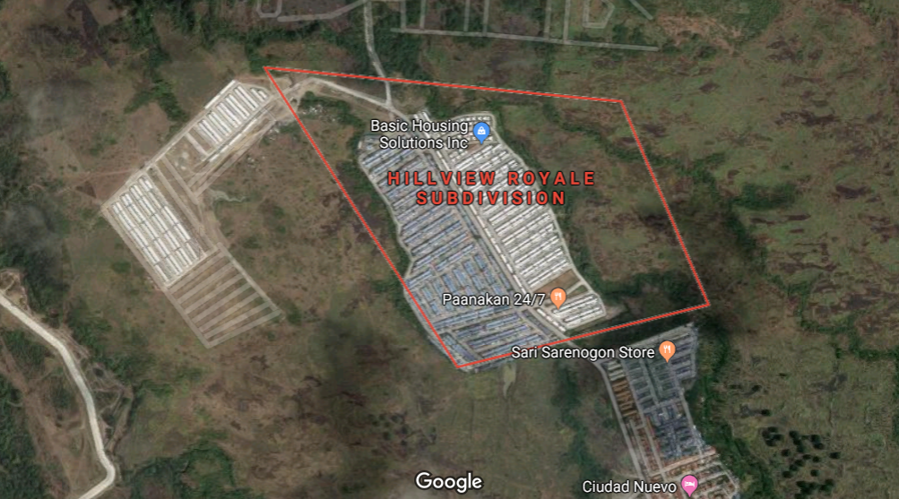

**COMPANY ORGANIZATIONAL CHART**

Nestor A. Trinidad  
President/Gen.Manager

Engr. Reynaldo Caranto  
Project Manager

Engr. Ma. Larie B. Billo  
Operation Manager

Arch. Ramon Dugtong  
Consultant

Gemma C. Trinidad  
Finance & Admin

Ma. Luisa Carla C. Trinidad  
Secretary

Engr. Joewil Sy  
Project Manager

Engr. Felix De Jesus  
Field Engr.

Jobert Mendoza  
General Foreman

Leadman

Const. Foreman

Skilled Worker

Semi-skilled Worker

**GALLERY ( BUSINESS ESTABLISHMENT )**

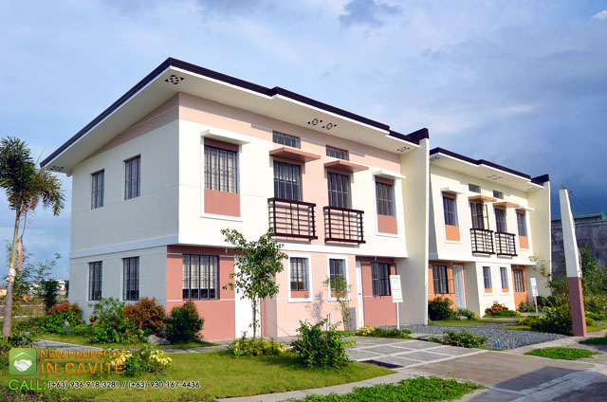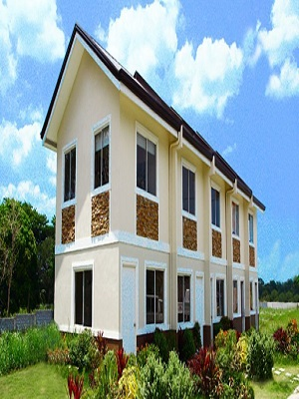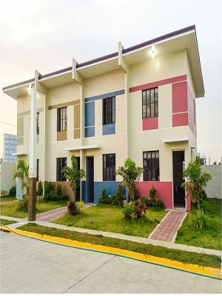

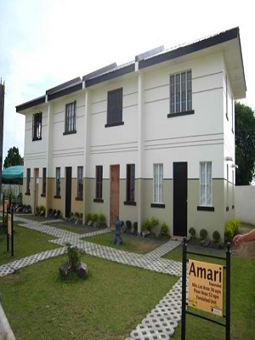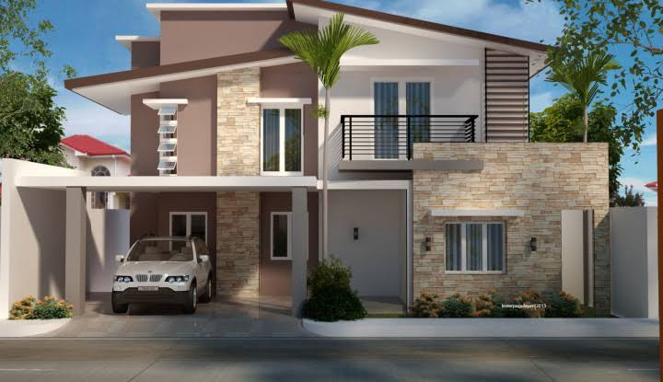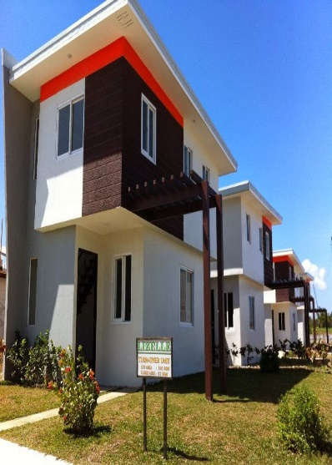

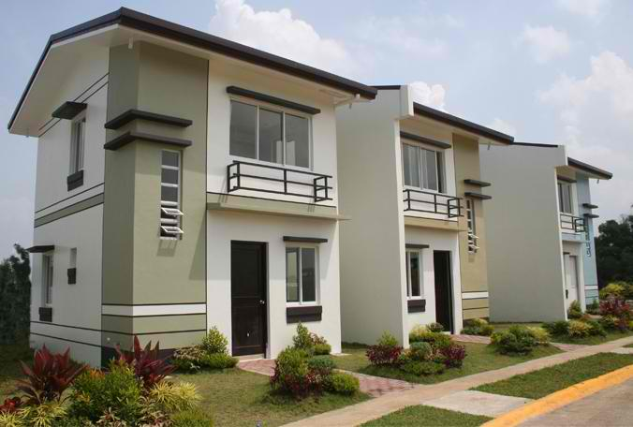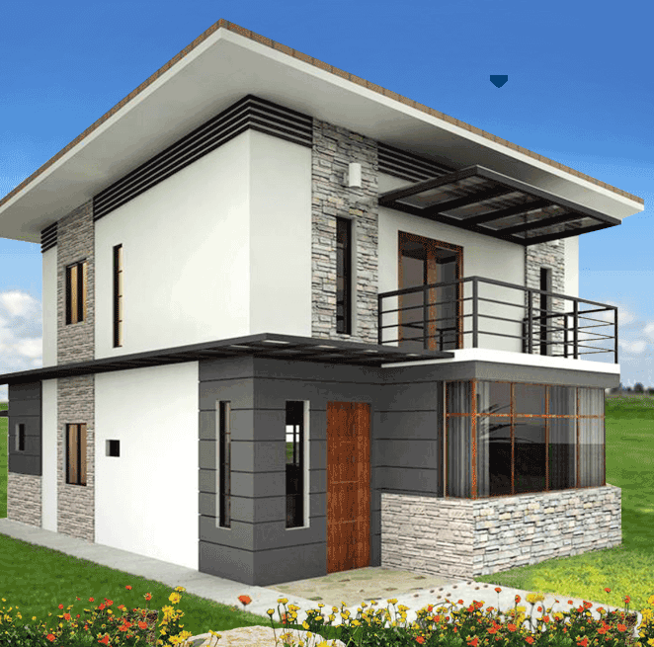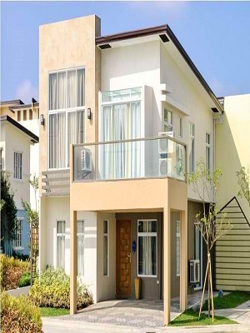

**WEB CONTENT**

The inside content of every pages in N.A.T Construction and Trading Company website.

* Home
  + Company Background
  + Company Mission
  + Company Vision
* Contact
  + Contact Form
* More Information
  + Company Services
  + Company Completed Project
  + Company On-going Project
* Footer
  + Company Information

**SITEMAP**

WEBSITE

ABOUT

MORE INFORMATION

CONTACT

Service / Product

Company Background

Send Message Form

Contact Information

4 Latest Project Completed

Mission/Vision

On-Going Project

**SCREENSHOTS**

**Home Menu**



**Contact Menu**

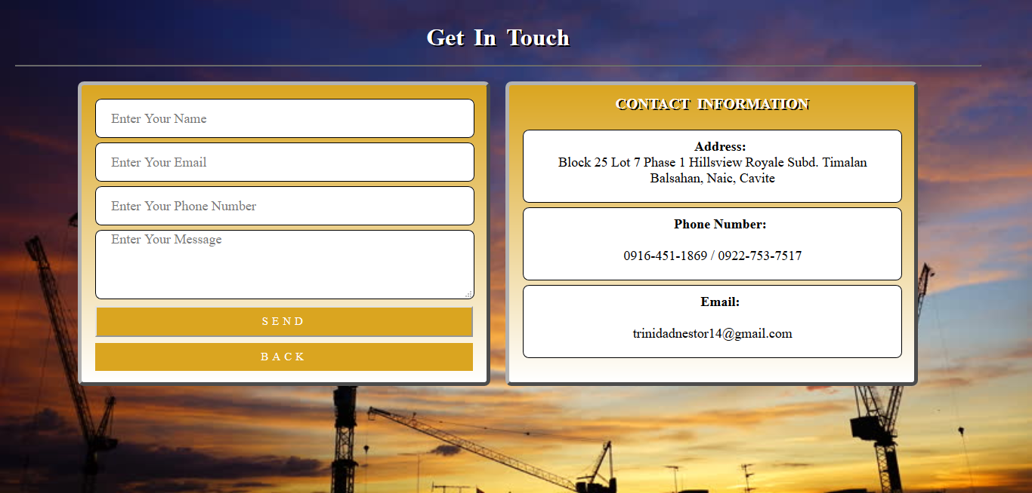

**More Information Menu Front**



More Information Menu Services



More Information Menu Project Completed

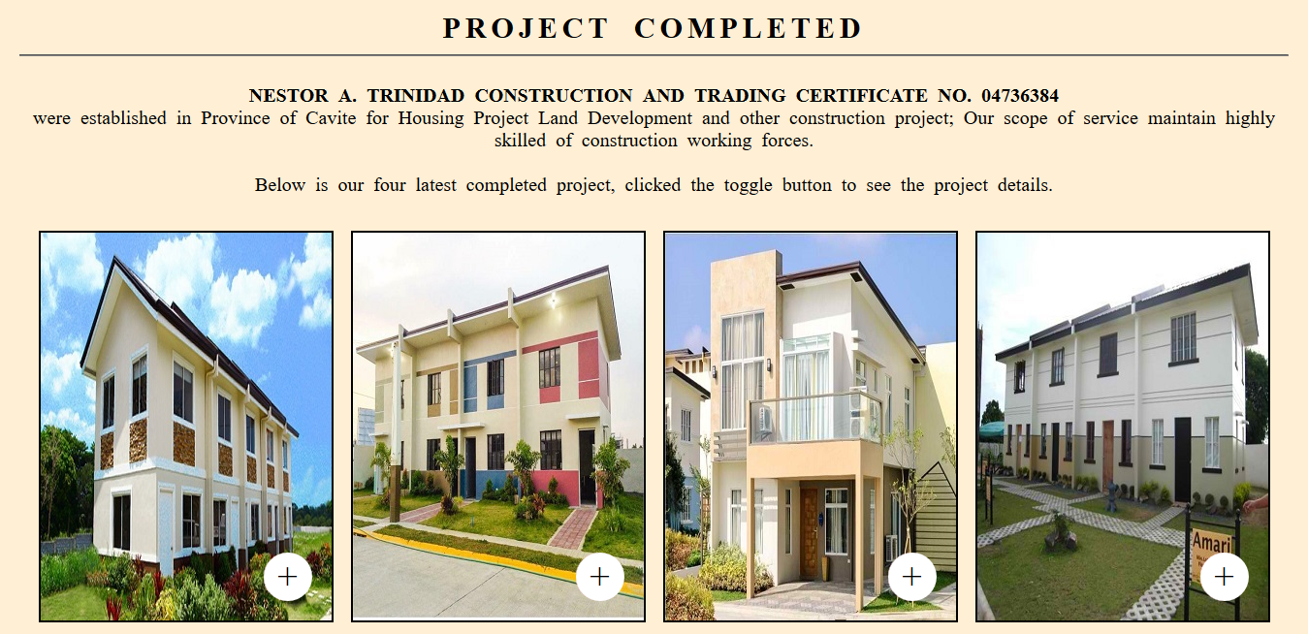

More Information Menu Project Completed (After Clicking Toggle Button)

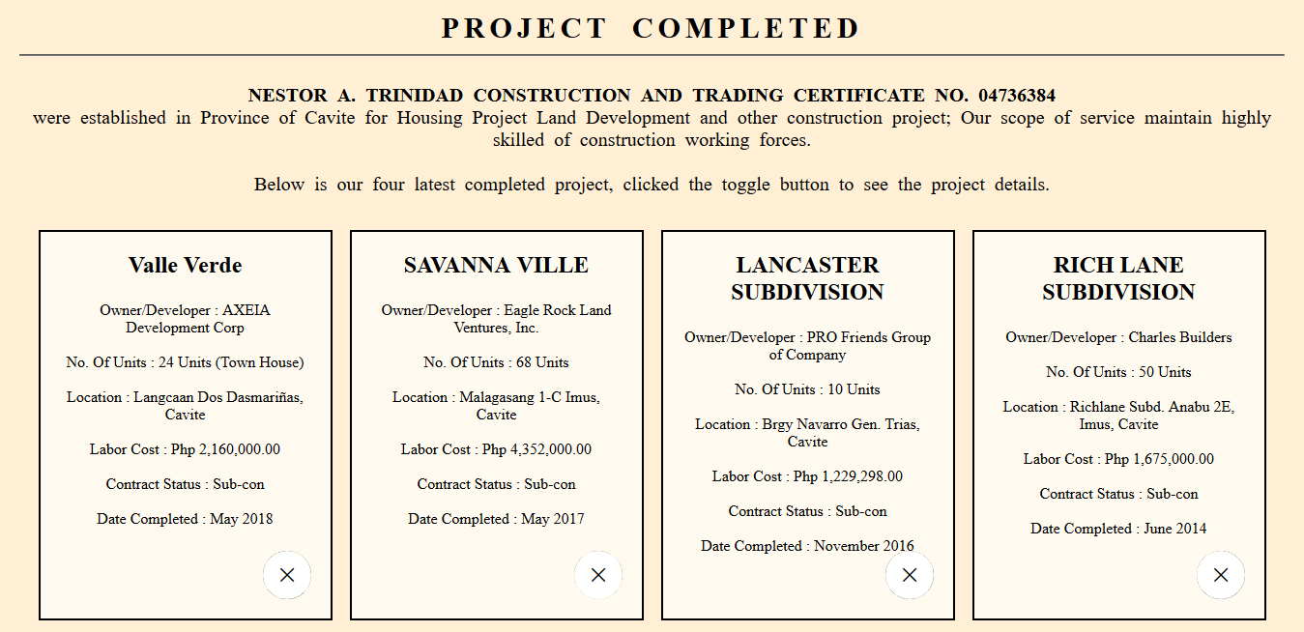

More Information Menu On-going Project

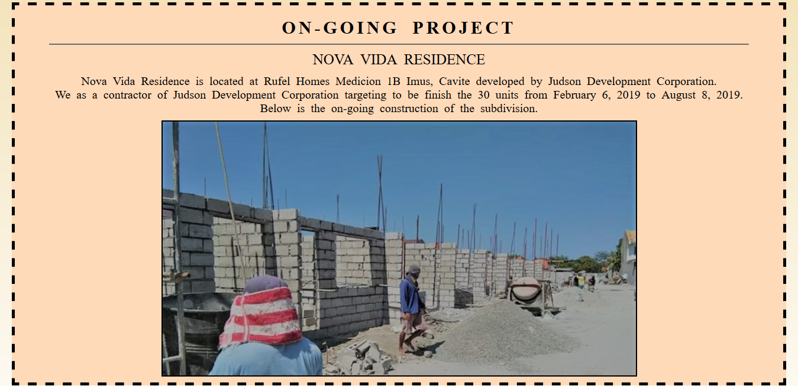

**SOURCE CODE**

**Index.html code**

<!DOCTYPE html>

<html>

<head>

<title> N.A.T Construction and Trading</title>

<link rel="stylesheet" type="text/css" href="style.css">

<meta charset="UTF-8">

<meta name="viewport" content="width=device-width, initial-scale=1.0">

<meta http-equiv="X-UA-Compatible" content="ie=edge">

</head>

<body>

<div class="container1">

<div class="main" id="top">

<nav class="navbar">

<span class="open-slide">

<a href="#" onclick="openSlideMenu()">

<svg width="30" height="30">

<path d="M0,5 30,5" stroke="#fff" stroke-width="5"/>

<path d="M0,14 30,14" stroke="#fff" stroke-width="5"/>

<path d="M0,23 30,23" stroke="#fff" stroke-width="5"/>

</svg>

</a>

</span>

<div class="logo">

<img src="logo.png" width="200" height="80">

</div>

<ul class="navbar-nav" >

<li><a href="index.html">Home</a></li>

<li><a href="contact.html">Contact</a></li>

<li><a href="moreInfo.html">More Information</a></li>

</ul>

</nav>

<div id="side-menu" class="side-nav">

<a href="#" class="btn-close" onclick="closeSlideMenu()">&times;</a>

<a href="index.html">Home</a>

<a href="contact.html">Contact</a>

<a href="moreInfo.html">More Information</a>

</div>

<script>

function openSlideMenu(){

document.getElementById('side-menu').style.width = '250px';

document.getElementById('main').style.marginRight = '250px';

}

function closeSlideMenu(){

document.getElementById('side-menu').style.width = '0';

document.getElementById('main').style.marginRight = '0';

}

</script>

<div class="intro1">

<h2> N.A.T Construction and Trading </h2>

<h4> " We don't finish houses, we finish homes." </h4>

</div>

</div>

<!--================ Introduction Start here =================-->

<div class="container">

<div class="house1">

<img class="img-fluid" src="img/house-2-storey.jpeg" alt="Two Storey House">

</div>

<div class="design_left_text">

<h6 class="welcome">About</h6>

<p class="intro"> Home is where we raise our families and experience <br> most of life's greatest joys. It's where the vast majority of our memories are maid. <br> We'll never forget that at cutting edge trim, <br> <br> <strong> WE DON'T FINISH HOUSES, WE FINISH HOMES.</strong> </p>

<a class="main_btn" href="moreInfo.html">More About Us</a>

</div>

</div>

<!--================ Introduction End here =================-->

<!--================ Goals Start here =======================-->

<div class="container">

<div class="Mission">

<h3> Mission </h3>

<br>

<p> Our mission is to provide reliable, top quality <br> carpentry services to the building industry. </p>

</div>

<div class="Vision">

<h3> Vision </h3>

<br>

<p> Our vision is to help to contribute a comfortable lifestyle and work environment <br> for our clients, employees and of course the end users of our products. </p>

</div>

</div>

<div class="scroll">

<a href="#top"> Go To Top </a>

</div>

<!--============ ==== Footer here =======================-->

<div class="footer" style="clear: both; width: 100%; height: 100px; background-color: #000; opacity: 0.6; line-height: 25px; display: inline-block; text-decoration: none; color: white; text-align:center; font-size:15pt; overflow: hidden;">

N.A.T Construction and Trading <br>

Address: Block 25 Lot 7 Phase 1 Hillsview Royale Timalan Balsahan, Naic, Cavite <br> Contact No: 0916-451-1869 / 0922-753-7517 <br> Email Address:<vlink> trinidadnestor14@gmail.com </vlink>

</div>

</div>

</body>

</html>

**contact.html code**

<!DOCTYPE html>

<html dir="ltr">

<head>

<title>N.A.T.C.T Contact Form </title>

</head>

<body>

<div class="contact-form">

<h1>Get In Touch </h1>

<hr>

<br>

<div class="txtb">

<input type="text" id="fullname" name="fullname" value="" placeholder="Enter Your Name" />

</div>

<div class="txtb">

<input type="email" id="email" name="email" value="" placeholder="Enter Your Email" />

</div>

<div class="txtb">

<input type="text" id="number" name="number" value="" placeholder="Enter Your Phone Number" />

</div>

<div class="txtb">

<textarea type="text" id="message" name="message" value="" placeholder="Enter Your Message"></textarea>

</div>

<button onclick="submit()" class="btn">Send</button>

<a class="btn" href="index.html">Back</a>

<script>

function submit(){

var fullname = document.getElementById('fullname').value;

var email = document.getElementById('email').value;

var number = document.getElementById('number').value;

var message = document.getElementById('message').value;

if (fullname == "" && email =="" && number =="" && message=="") {

alert ("Fill in all required field");

}

if ( fullname =="" || email==""|| number ==""|| message=="") {

alert ("Fill in all required field. Thank you.");

}

else {

alert ("Thank you.");

return true;

}

}

</script>

</div>

</body>

</html>

**moreInfo.html code**

<!DOCTYPE html>

<html>

<head>

<title> N.A.T Construction and Trading</title>

<link rel="stylesheet" type="text/css" href="style.css">

<meta charset="UTF-8">

<meta name="viewport" content="width=device-width, initial-scale=1.0">

<meta http-equiv="X-UA-Compatible" content="ie=edge">

</head>

<body>

<div class="container1">

<div class="main" style="background-image: url(moreinfo.jpeg);">

<nav class="navbar">

<span class="open-slide">

<a href="#" onclick="openSlideMenu()">

<svg width="30" height="30">

<path d="M0,5 30,5" stroke="#fff" stroke-width="5"/>

<path d="M0,14 30,14" stroke="#fff" stroke-width="5"/>

<path d="M0,23 30,23" stroke="#fff" stroke-width="5"/>

</svg>

</a>

</span>

<div class="logo">

<img src="logo.png" width="200" height="80">

</div>

<ul class="navbar-nav">

<li><a href="index.html">Home</a></li>

<li><a href="contact.html">Contact</a></li>

<li><a href="moreInfo.html">More Information</a></li>

</ul>

</nav>

<div id="side-menu" class="side-nav">

<a href="#" class="btn-close" onclick="closeSlideMenu()">&times;</a>

<a href="index.html">Home</a>

<a href="contact.html">Contact</a>

<a href="moreInfo.html">More Information</a>

</div>

<script>

function openSlideMenu(){

document.getElementById('side-menu').style.width = '250px';

document.getElementById('main').style.marginRight = '250px';

}

function closeSlideMenu(){

document.getElementById('side-menu').style.width = '0';

document.getElementById('main').style.marginRight = '0';

}

</script>

<div class="intro1">

<h2 style="color: white;text-shadow: 3px 3px black;"> N.A.T Construction and Trading </h2>

<br>

<h4 style="color: black;text-shadow: 3px 3px white;"> More Information </h4>

</div>

</div>

<!--================ Services Start here =======================-->

<section class="feature_area">

<div class="container">

<div class="main_title">

<p class="services">What we offer to our clients</p>

<hr> <br>

<p class="services1"><b> N.A.T CONSTRUCTION AND TRADING </b> maintained <br> in the preparation of technical and project monitoring and control financial management and overall project administration.<br> It has also equipment for faster implementation of construction project and enough manpower.</p>

</div>

<div class="box">

<div class="box-row">

<div class="box-cell box1">

<img src="img/icon/f-icon-1.png" alt="manpower">

<br><br>

<h4>Carpentry</h4>

<br><br>

<p>We give excellent and best carpentry which build best home that a client feels comfortable</p>

</div>

<div class="box-cell box2">

<img src="img/icon/f-icon-2.png" alt="paintbrush">

<br><br>

<h4>Painting</h4>

<br><br>

<p>We specialize paintings that can caught an eye and promotes high quality of paintings for a better and remarkable home.</p>

</div>

<div class="box-cell box3">

<img src="img/icon/f-icon-3.png" alt="floor">

<br><br>

<h4>Flooring Work</h4>

<br><br>

<p>We give excellent flooring works which build best home that a client feels comfortable with and will feel at home.</p>

</div>

<div class="box-cell box4">

<img src="img/icon/f-icon-4.png" alt="wood">

<br><br>

<h4>Wooden Work</h4>

<br><br>

<p>We give excellent wooden works which build best home that a client feels comfortable with and will feel at home.</p>

</div>

</div>

</div>

</div>

</section>

<!--================ Services End here =======================-->

<!--================= Project Completed =======================-->

<section class="ProjectCompleted" style="background: #FFEFD5; background-size: cover; background-position: center;background-repeat: no-repeat;">

<div class="container">

<div class="main_title">

<h1 class="services"> PROJECT COMPLETED </h1>

<hr> <br>

<p class="services1"><b> NESTOR A. TRINIDAD CONSTRUCTION AND TRADING CERTIFICATE NO. 04736384 </b> <br> were established in Province of Cavite for Housing Project Land Development and other construction project. Our scope of service is to maintain highly skilled of construction working forces. <br><br> Below is our four latest completed project, clicked the toggle button to see the project details. </p> <br>

</div>

<div id="pic">

<input type="checkbox" name="">

<div class="toggle"> + </div>

<div class="imgBx">

<img src="img/ProjectCompleted/valleverde.jpg">

</div>

<div class="details">

<h2> Valle Verde </h2>

<br>

<p> Owner/Developer : AXEIA Development Corp <br><br>

No. Of Units : 24 Units (Town House) <br><br>

Location : Langcaan Dos Dasmariñas, Cavite <br><br>

Labor Cost : Php 2,160,000.00 <br><br>

Contract Status : Sub-con <br><br>

Date Completed : May 2018

</p>

</div>

</div>

<div id="pic">

<input type="checkbox" name="">

<div class="toggle"> + </div>

<div class="imgBx">

<img src="img/ProjectCompleted/savannaville.jpg">

</div>

<div class="details">

<h2> SAVANNA VILLE </h2>

<br>

<p> Owner/Developer : Eagle Rock Land Ventures, Inc. <br><br>

No. Of Units : 68 Units <br><br>

Location : Malagasang 1-C Imus, Cavite <br><br>

Labor Cost : Php 4,352,000.00 <br><br>

Contract Status : Sub-con <br><br>

Date Completed : May 2017

</p>

</div>

</div>

<div id="pic">

<input type="checkbox" name="">

<div class="toggle"> + </div>

<div class="imgBx">

<img src="img/ProjectCompleted/LANCASTER.jpg">

</div>

<div class="details">

<h2> LANCASTER SUBDIVISION </h2>

<br>

<p> Owner/Developer : PRO Friends Group of Company <br><br>

No. Of Units : 10 Units <br><br>

Location : Brgy Navarro Gen. Trias, Cavite <br><br>

Labor Cost : Php 1,229,298.00 <br><br>

Contract Status : Sub-con <br><br>

Date Completed : November 2016 <br>

</p>

</div>

</div>

<div id="pic">

<input type="checkbox" name="">

<div class="toggle"> + </div>

<div class="imgBx">

<img src="img/ProjectCompleted/richlane.jpg">

</div>

<div class="details">

<h2>RICH LANE SUBDIVISION</h2>

<br>

<p> Owner/Developer : Charles Builders <br><br>

No. Of Units : 50 Units <br><br>

Location : Richlane Subd. Anabu 2E, Imus, Cavite <br><br>

Labor Cost : Php 1,675,000.00 <br><br>

Contract Status : Sub-con <br><br>

Date Completed : June 2014 <br>

</p>

</div>

</div>

</div>

</section>

<!--============= ONGOING PROJECT GALLERY ================-->

<section class="OnGoing" >

<div class="container" style="background: #FFDAB9; background-size: cover; background-position: center;background-repeat: no-repeat;">

<div class="main_title">

<h1 class="services"> ON-GOING PROJECT </h1>

<hr>

<p class="services3"> NOVA VIDA RESIDENCE</p>

<p class="services1">Nova Vida Residence is located at Rufel Homes Medicion 1B Imus, Cavite developed by Judson Development Corporation. <br> We as a contractor of Judson Development Corporation targeting to be finish the 30 units from February 6, 2019 to August 8, 2019.<br> Below is the on-going construction of the subdivision. </p>

</div>

<div class="slider">

</div>

</div>

</section>

<div class="scroll">

<a href="#top"> Go To Top </a>

</div>

<!--============ ==== Footer here =======================-->

<div class="footer" style="clear: both; width:100%; height: 100px; background-color: #000; opacity: 0.6; line-height: 25px; display: inline-block; text-decoration: none; color: white; text-align:center; font-size:15pt; overflow: hidden;">

N.A.T Construction and Trading <br>

Address: Block 25 Lot 7 Phase 1 Hillsview Royale Timalan Balsahan, Naic, Cavite <br> Contact No: 0916-451-1869 / 0922-753-7517 <br> Email Address:<vlink> trinidadnestor14@gmail.com </vlink>

</div>

</body>

</html>

**style.css code**

*

{

margin: 0;

padding: 0;

font-family: Times New Roman;

}

html

{

scroll-behavior: smooth;

}

body

{

background: linear-gradient(GoldenRod ,white);

background-size: cover;

background-position: center;

background-repeat: no-repeat;

}

.main

{

background-image: url(home-banner.jpeg);

background-size: cover;

background-position: center;

height: 600px;

overflow: hidden;

}

.scroll a

{

float: right;

margin: 0 120px 10px 10px ;

padding: 10px;

width: 100px;

text-align: center;

text-decoration: none;

font-size:20px;

color: #000;

background:#F5DEB3;

border: 2px solid black;

border-radius: 25%;

box-shadow: 5px 5px 10px rgba(0, 0, 0, 0.5);

animation: pulse 5s infinite;

}

@keyframes pulse {

0% {

background-color:#FFFFE0;

}

100% {

background-color:#8B4513;

}

}

/*-- Navigation Bar --*/

.logo

{

float: left;

padding: 10px;

}

.navbar

{

background-color:#000;

opacity: 0.6;

height:100px;

}

.navbar a

{

float:left;

display:block;

color:#f2f2f2;

text-align:center;

padding:14px 16px;

text-decoration:none;

}

.navbar-nav

{

float: right;

display: flex;

font-size:30px;

}

.navbar ul

{

margin:8px 10px 0 0;

list-style:none;

}

.navbar a:hover

{

background-color:#ddd;

color:#000;

}

.side-nav

{

height:100%;

width:0;

position:fixed;

z-index:1;

top:0;

left:0;

background-color:#111;

opacity:0.9;

overflow-x:hidden;

padding-top:60px;

transition:0.5s;

}

.side-nav a

{

padding:10px 10px 10px 30px;

text-decoration:none;

font-size:22px;

color:#ccc;

display:block;

transition:0.3s;

}

.side-nav a:hover

{

color:#fff;

}

.side-nav .btn-close

{

position:absolute;

top:0;

right:22px;

font-size:36px;

margin-left:50px;

}

#main

{

transition:margin-left 0.5s;

padding:20px;

overflow:hidden;

width:100%;

}

@media(max-width:568px)

{

.navbar-nav{display:none}

}

@media(min-width:568px)

{

/*.open-slide{display:none}*/

}

/*-- Banner --*/

.intro1

{

display: inline;

height: 80%;

align-items: center;

justify-content: center;

text-align: center;

padding: 90px;

letter-spacing: 5px;

}

.intro1 h2

{

padding-top: 50px;

font-family:"Berlin Sans FB Demi";

font-size: 50px;

color:black;

word-wrap: break-word;

}

.intro1 h4

{

font-size: 30px;

font-style: italic;

color:black;

}

/*-- Introduction --*/

.container

{

margin: 10px;

padding: 10px;

display: flex;

flex-flow: row wrap;

overflow: hidden;

align-items: center;

justify-content: center;

text-align: center;

}

.house1, .design_left_text

{

padding: 30px;

}

.house1

{

height: 300px;

width: 350px;

}

.house1 img

{

border: 1px solid #008080;

border-radius: 5px;

box-shadow: 0 0 20px #000000b3;

height: 100%;

width: 100%;

}

.welcome

{

font-size: 30px;

}

.intro

{

font-size: 25px;

}

.main_btn

{

padding: 0px 40px;

background: #008080;

z-index: 2;

display: inline-block;

transition: all 400ms linear;

text-align: center;

color: #fff;

font-size: 14px;

font-weight: 600;

font-family: "Roboto", sans-serif;

line-height: 48px;

border: 1px solid #008080;

border-radius: 5px;

transition: all 300ms linear 0s;

box-shadow: 0px 10px 30px 0px rgba(115, 73, 251, 0.3);

margin-top: 30px;

}

.container:hover

{

box-shadow: 0px 10px 30px 0px rgba(0, 0, 0, 0.08);

border-color: #fff;

}

.Mission, .Vision

{

margin: 20px;

padding: 20px;

width: 500px;

height: 230px;

text-align: center;

border: 1px solid #008080;

border-radius: 5px;

box-shadow: 0px 10px 30px 0px rgba(115, 73, 251, 0.3);

background: #FFDAB9;

}

.Mission h3, .Vision h3

{

font-size: 35px;

}

.Mission p, .Vision p

{

font-size: 20px;

}

//*==== Footer End Here ===*//

.footer

{

clear: both;

padding: 5px;

width: 100%;

height: 100px;

background-color: #000;

opacity: 0.6;

line-height: 25px;

display: inline-block;

text-decoration: none;

color: white;

text-align:center;

font-size:15pt;

}

/*-- Services --*/

.feature_area .container

{

background: #FFF;

background-size: cover;

background-position: center;

background-repeat: no-repeat;

}

.services

{

margin: 10px 0 10px 0;

font-size: 30px;

text-transform: uppercase;

font-weight: bold;

word-spacing: 10px;

letter-spacing: 5px;

text-align: center;

}

.services1

{

margin: 10px;

font-size: 20px;

word-spacing: 5px;

text-align: center;

}

.services3 {

margin: 10px;

font-size: 25px;

word-spacing: 5px;

text-align: center;

}

.feature_area

{

margin: 0;

padding: 10px;

}

.feature_area .container {

border: 5px solid black;

}

.container .box .box-row

{

display: flex;

flex-flow: row wrap;

width: 100%;

align-items: center;

justify-content: center;

align-content: center;

}

.container .box .box-row .box-cell

{

display: table-cell;

border-radius: 10px;

transition: all 300ms linear 0s;

width: 250px;

height: 300px;

padding: 20px;

margin: 5px;

background: #FFEBCD;

}

.box-row img

{

padding: 10px;

height: 60px;

width: 60px;

}

.box-row h4 {

color: #222222;

font-size: 20px;

font-family: "Heebo", sans-serif;

font-weight: 600;

margin-bottom: 20px;

}

.box-row p

{

margin-bottom: 36px;

font-size: 20px;

}

.box-row .main_btn

{

padding: 0px 30px;

line-height: 38px;

}

.box-row:hover

{

box-shadow: 0px 10px 30px 0px rgba(0, 0, 0, 0.08);

border-color: #fff;

}

//*=== Project Completed Start Here ====*//

.ProjectCompleted

{

background: #FFEFD5;

background-size: cover;

background-position: center;

background-repeat: no-repeat;

}

#pic

{

position: relative;

width: 300px;

height: 400px;

background: #262626;

overflow: hidden;

margin: 9px;

border: 2px solid black;

}

input, .toggle

{

position: absolute;

width: 50px;

height:50px;

bottom: 20px;

right: 20px;

outline: none;

z-index: 10;

}

input

{

opacity: 0;

}

.toggle

{

pointer-events: none;

border-radius: 75%;

background: #fff;

transition: 0.5s;

text-align: center;

line-height: 50px;

font-size: 36px;

box-shadow: 0 0 0 0px #FFC0CB;

}

input:checked ~ .toggle

{

box-shadow: 0 0 0 500px #FFFAF0;

transform: rotate(225deg);

}

.imgBx, .details

{

position: absolute;

top: 0;

left:0;

width: 100%;

height: 100%;

}

.details

{

padding: 20px;

box-sizing: border-box;

border-bottom-color: 2px solid white;

z-index: 11;

pointer-events: none;

opacity:0;

}

input:checked ~.details

{

pointer-events: none;

opacity: 1;

transition-delay: 0.5s;

}

.details h2

{

margin-bottom: 5px;

color: black;

}

.details p

{

margin:0;

padding:0;

color: black;

}

/* ONGOING PROJECT GALLERY */

.OnGoing {

padding: 10px;

}

.OnGoing .container {

background: #FFDAB9;

background-size: cover;

background-position: center;

background-repeat: no-repeat;

border: 5px dashed black;

}

.slider {

width: 800px;

height: 430px;

background: url(img/OnGoing/nova1.jpg);

background-size: cover;

animation: slide 20s infinite;

border: 2px solid black;

}

@keyframes slide {

10%{

background: url(img/OnGoing/nova2.jpg);

background-size: cover;

}

20%{

background: url(img/OnGoing/nova3.jpg);

background-size: cover;

}

30%{

background: url(img/OnGoing/nova4.jpg);

background-size: cover;

}

40%{

background: url(img/OnGoing/nova5.jpg);

background-size: cover;

}

50%{

background: url(img/OnGoing/nova2.jpg);

background-size: cover;

}

60%{

background: url(img/OnGoing/nova3.jpg);

background-size: cover;

}

70%{

background: url(img/OnGoing/nova4.jpg);

background-size: cover;

}

80%{

background: url(img/OnGoing/nova5.jpg);

background-size: cover;

}

90%{

background: url(img/OnGoing/nova5.jpg);

background-size: cover;

}

100%{

background: url(img/OnGoing/nova5.jpg);

background-size: cover;

}

}

/* Contact */

.contact-form

{

width: 85%;

max-width: 600px;

background: linear-gradient(#FFDAB9 ,white);

position: absolute;

top: 50%;

left: 50%;

transform: translate(-50%,-50%);

padding: 30px 40px;

box-sizing: border-box;

border-radius: 8px;

text-align: center;

box-shadow: 0 0 20px #000000b3;

font-family: 'Bookman Old Style';

}

.contact-form h1

{

margin-top: 0;

font-weight: 200;

}

.contact-form .txtb

{

border:1px solid gray;

margin: 8px 0;

padding: 12px 18px;

border-radius: 8px;

}

.contact-form .txtb label

{

display: block;

text-align: left;

color: #333;

text-transform: uppercase;

font-size: 14px;

}

.contact-form .txtb input,.txtb textarea

{

width: 100%;

border: none;

background: none;

outline: none;

font-size: 18px;

margin-top: 6px;

font-family: 'Bookman Old Style';

}

.contact-form .btn

{

display: inline-block;

background: #DAA520;

padding: 14px 0;

color: white;

text-transform: uppercase;

cursor: pointer;

margin-top: 8px;

width: 100%;

}

**ABOUT THE DEVELOPERS**

**Chica Jude Allan** is the youngest child of Roberto Pabiton and Liza Chica. He was born on May 28, 1999. He is presently residing in 0523 Sampaguita St. Timalan, Naic Cavite. He finished primary education at Sabang Naic Cavite, Junior high School at Centro de Naic and Senior High School at Western Colleges Inc. and currently taking his College education at Cavite State University Naic Campus with a course of Bachelor of Science in Information Technology.

**Trinidad Ma. Luisa Carla Caligner** is the first and oldest child of Nestor Trinidad and Gemma Trinidad. She was born on March 15, 2000. She is presently residing in Block 58 Lot 1 Phase 2 Villa Apolonia Subdivision, Ibayo Silangan, Naic Cavite together with her family. She finished her primary education at Naic Elementary School in 2012, Junior High School at Western Colleges Inc. in 2016 and Senior High School at Lav Laize Integrated School in 2018. She is now facing college life with a course of Bachelor of Science in Information Technology at Cavite State University Naic Campus.

**EVALUATION RESULT**